Aim: To implement AJAX applications that enable asynchronous communication with servers without reloading the webpage.

Q1. What is AJAX?
AJAX (Asynchronous JavaScript and XML) is a web development technique that allows web pages to communicate with a server asynchronously—sending and receiving data in the background without reloading the entire webpage. It enables dynamic content updates, improving user experience and performance.

Q2. What is an Asynchronous operation?
An asynchronous operation is a task that runs independently of the main program flow, allowing the program to continue executing other code while waiting for the task to complete.

Q3. Implement AJAX applications that enable asynchronous communication with servers without reloading the webpage.
Code (index.html):

<!doctype html>
<html lang="en">
<head>
<meta charset="UTF-8" />
<meta
name="viewport"
content="width=device-width, initial-scale=1.0, user-scalable=yes"
/>
</head>
<body>
<div class="ajax-card">
<div class="exp-header">
<h1>
AJAX Application
<small>Async Communication</small>
</h1>
<p>
Fetch and display data dynamically without page reload |
JSONPlaceholder API
</p>
</div>

<div class="control-panel">
<div class="btn-group">
<button id="fetchPostsBtn" class="btn btn-primary">
GET Posts (AJAX)
</button>
<button id="clearBtn" class="btn btn-outline">
Clear Data
</button>
</div>
<div class="status-area" id="statusWidget">
<span class="status-badge" id="statusLed"></span>
<span id="statusText">Ready</span>
</div>
</div>

<div class="output-container">
<div class="section-title">Live Data from Server</div>
<div id="dataDisplay" class="data-grid">
<div class="placeholder-message">
Click the <strong>"GET Posts"</strong> button to fetch
data asynchronously.<br />
AJAX request will be sent to JSONPlaceholder API and
display posts dynamically.
</div>
</div>
</div>
</div>

<script>
const fetchBtn = document.getElementById("fetchPostsBtn");
const clearBtn = document.getElementById("clearBtn");
const dataDisplayDiv = document.getElementById("dataDisplay");
const statusLed = document.getElementById("statusLed");
const statusTextSpan = document.getElementById("statusText");

function updateStatus(message, isLoading = false, isError = false) {
statusTextSpan.textContent = message;
if (isLoading) {
statusLed.className = "status-badge active";

statusLed.style.background = "#facc15";
statusLed.style.boxShadow = "0 0 0 2px #fef9c3";
} else if (isError) {
statusLed.className = "status-badge";
statusLed.style.background = "#ef4444";
statusLed.style.boxShadow = "0 0 0 2px #fee2e2";
} else {
statusLed.className = "status-badge";
statusLed.style.background = "#22c55e";
statusLed.style.boxShadow = "none";
}
if (!isLoading && !isError) {
statusLed.style.background = "#22c55e";
}
if (!isLoading && !isError && message === "Ready") {
statusLed.style.background = "#94a3b8";
}
}

function showLoadingSkeleton() {
dataDisplayDiv.innerHTML = `
<div class="placeholder-message" style="display: flex; align-items: center; justify-content: center; gap: 12px;">
<span class="loader"></span> Fetching data from server, please wait...
</div>
`;
}

function renderPosts(postsArray) {
if (!postsArray || postsArray.length === 0) {
dataDisplayDiv.innerHTML = `<div class="placeholder-message"> No posts found. Try again later.</div>`;
return;
}

const fragment = document.createDocumentFragment();
const gridContainer = document.createElement("div");
gridContainer.className = "data-grid";

const limitedPosts = postsArray.slice(0, 12);

limitedPosts.forEach((post) => {
const postCard = document.createElement("div");
postCard.className = "post-card";

const titleText = post.title ? post.title : "Untitled";
const bodyText = post.body
? post.body
: "No content available.";

postCard.innerHTML = `
<div class="post-title"> ${escapeHtml(titleText.substring(0, 70))}${titleText.length > 70 ? "..." : ""}</div>
<div class="post-body">${escapeHtml(bodyText.substring(0, 130))}${bodyText.length > 130 ? "..." : ""}</div>
<div class="post-meta"> Post ID: ${post.id} | User ID: ${post.userId}</div>
`;
gridContainer.appendChild(postCard);
});

fragment.appendChild(gridContainer);

dataDisplayDiv.innerHTML = "";
dataDisplayDiv.appendChild(fragment);
}

function escapeHtml(str) {
if (!str) return "";
return str
.replace(/[&<>]/g, function (m) {
if (m === "&") return "&amp;";
if (m === "<") return "&lt;";
if (m === ">") return "&gt;";
return m;
})
.replace(/[\uD800-\uDBFF][\uDC00-\uDFFF]/g, function (c) {
return c;
});
}

function showError(message) {
dataDisplayDiv.innerHTML = `
<div class="error-message">
${escapeHtml(message)}<br>
<span style="font-size:0.8rem;"> Tip: Check your internet or try again later.</span>
</div>
`;
updateStatus(`Error: ${message.substring(0, 50)}`, false, true);

setTimeout(() => {
if (statusTextSpan.innerText.includes("Error")) {
if (!window.activeAjaxRequest) {
updateStatus("Ready", false, false);
}
}
}, 3000);
}

function fetchPostsWithAJAX() {
updateStatus("Fetching data...", true, false);
showLoadingSkeleton();

const xhr = new XMLHttpRequest();

const apiUrl = "https://jsonplaceholder.typicode.com/posts";

xhr.open("GET", apiUrl, true);

xhr.setRequestHeader("Accept", "application/json");

xhr.onreadystatechange = function () {
if (xhr.readyState === 4) {
if (xhr.status === 200) {
try {
const responseData = JSON.parse(
xhr.responseText,
);

if (
Array.isArray(responseData) &&
responseData.length > 0
) {
renderPosts(responseData);
updateStatus(
` Loaded ${responseData.length} posts (AJAX success)`,
false,
false,
);

setTimeout(() => {
if (
statusTextSpan.innerText.includes(
"Loaded",
)
) {
updateStatus("Ready", false, false);
}
}, 2500);
} else {
dataDisplayDiv.innerHTML = `<div class="placeholder-message"> Server returned empty data. Nothing to display.</div>`;
updateStatus(
"No data received",
false,
false,
);
}
} catch (parseError) {
showError("Invalid JSON response from server.");
}
} else {
let errorMsg = `HTTP error ${xhr.status}: ${xhr.statusText}`;
if (xhr.status === 0) {
errorMsg =
"Network error or CORS / request blocked.";
}
showError(errorMsg);
}

window.activeAjaxRequest = false;
}
};

xhr.onerror = function () {
showError(
"Network failure. Please check your internet connection.",
);
window.activeAjaxRequest = false;
};

xhr.timeout = 15000;
xhr.ontimeout = function () {
showError(
"Request timeout. Server took too long to respond.",
);
window.activeAjaxRequest = false;
};

window.activeAjaxRequest = true;

xhr.send();
}

function clearData() {
dataDisplayDiv.innerHTML = `
<div class="placeholder-message">
Data cleared. Click <strong>"GET Posts"</strong> to fetch fresh data via AJAX.
</div>
`;
updateStatus("Ready", false, false);
}

fetchBtn.addEventListener("click", () => {
fetchPostsWithAJAX();
});

clearBtn.addEventListener("click", () => {
clearData();
});

updateStatus("Ready", false, false);

</script>
</body>
</html>

Output:
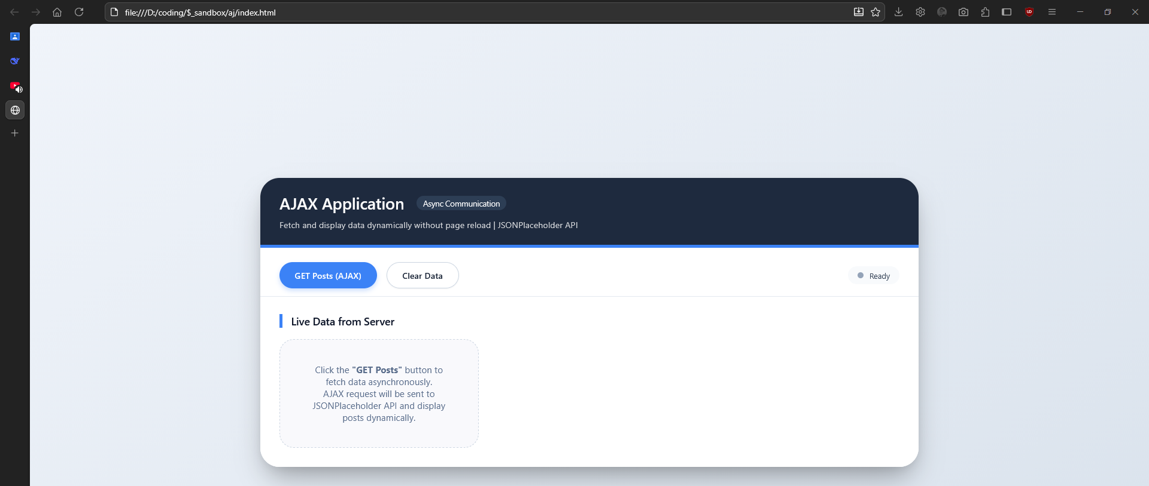

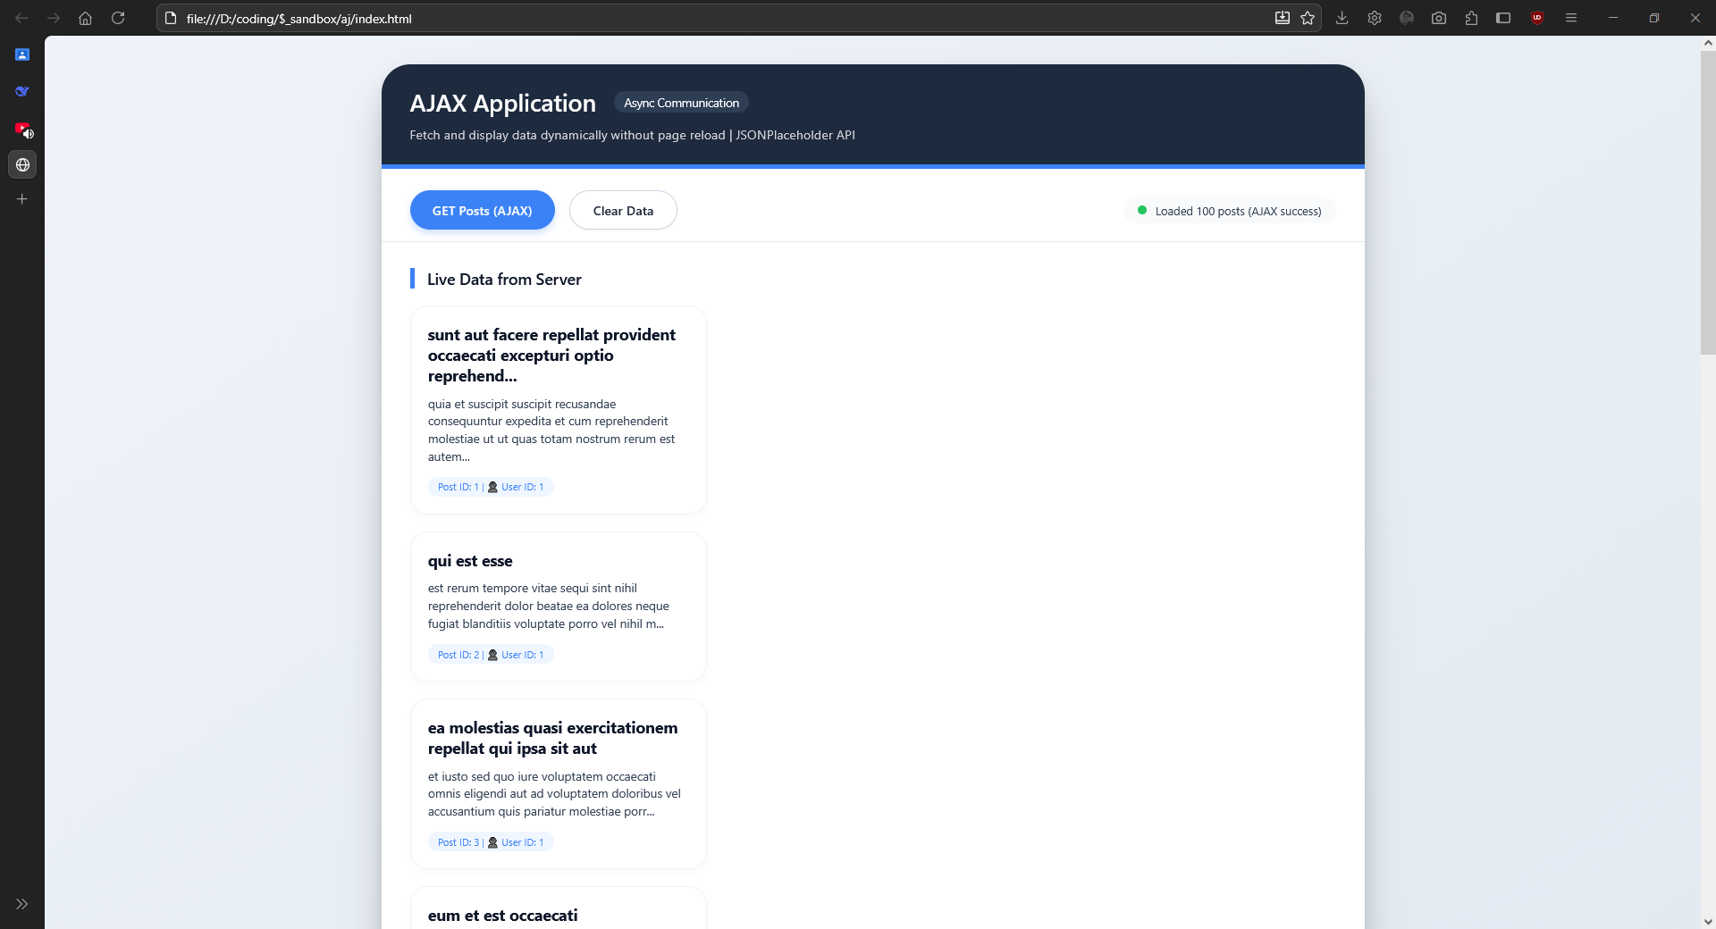

Conclusion:
Successfully implemented AJAX applications that enable asynchronous communication with servers without reloading the webpage.

